Multiple Browser

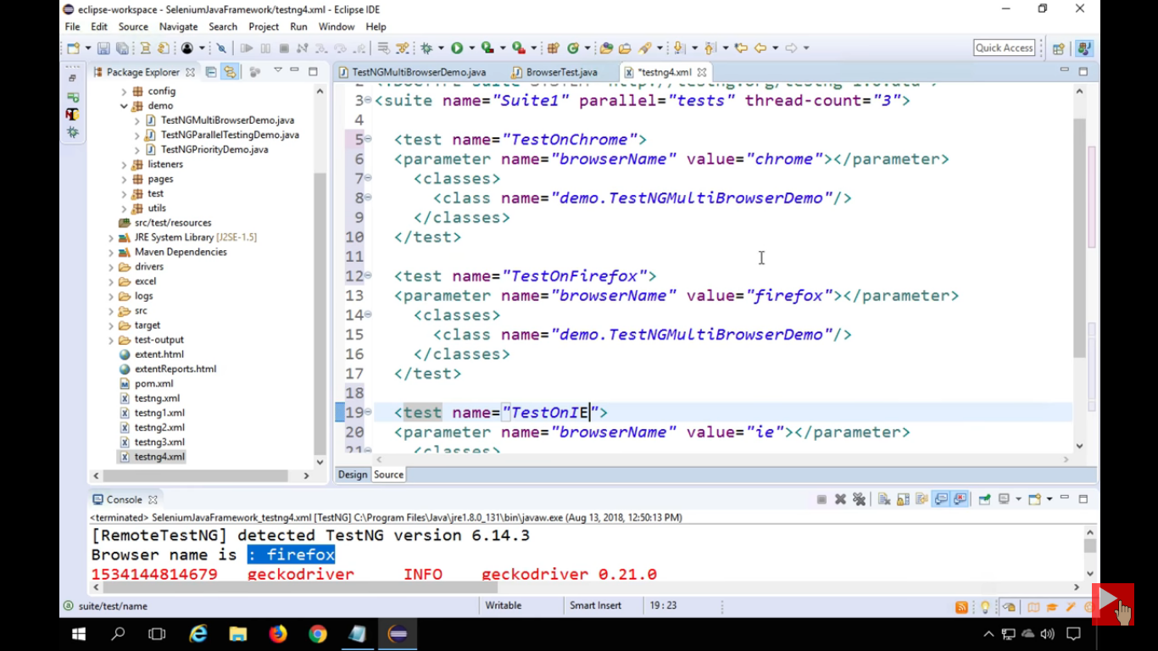

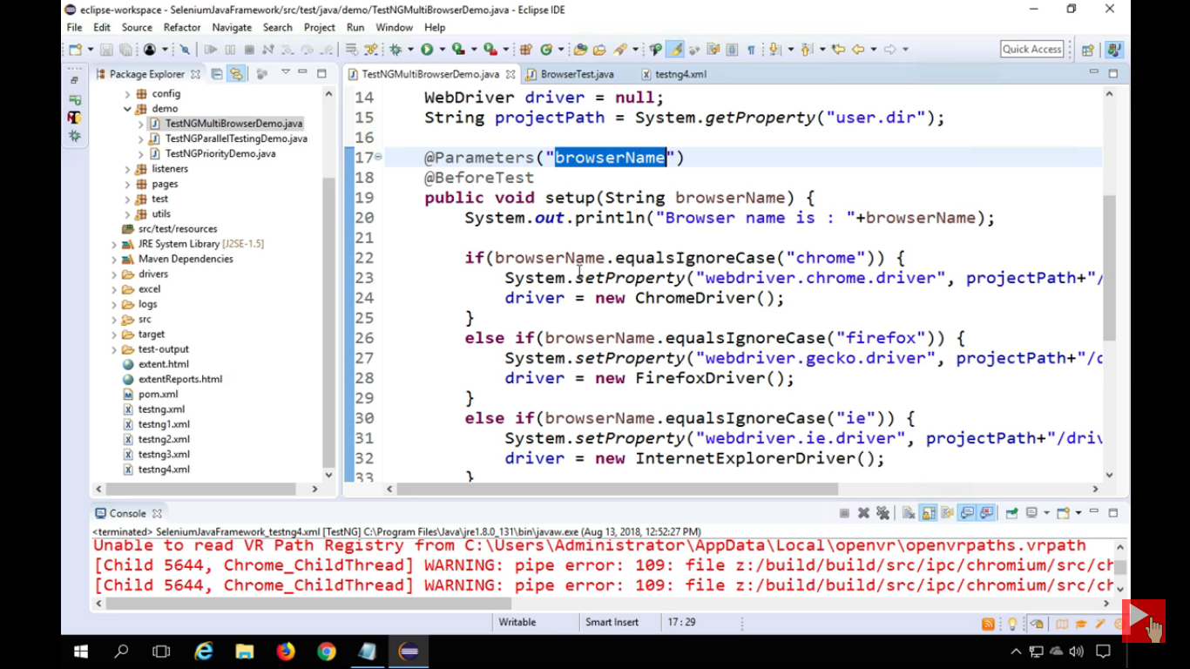

|  |
| --- |
| <?xml version="1.0" encoding="UTF-8"?>  <suite name="GRID SAMPLE TEST" thread-count="2">      <test name="GRID TEST WITH SERIAL EXECTION WITH BROWSER IE">      <parameter name ="browserType" value="IE"/>          <classes>              <class name ="GridExample"/>          </classes>      </test>      <test name="GRID TEST WITH SERIAL EXECTION WITH BROWSER FF ">      <parameter name ="browserType" value="firefox"/>          <classes>              <class name ="GridExample"/>          </classes>      </test>  </suite> |

To run the test parallel, you have to change your testng.xml like below.

|  |
| --- |
| <?xml version="1.0" encoding="UTF-8"?>  <suite name="GRID SAMPLE TEST" parllel="tests" thread-count="3">      <test name="GRID TEST WITH SERIAL EXECTION WITH BROWSER FF">      <parameter name ="browserType" value="firefox"/>          <classes>              <class name ="GridExample"/>          </classes>      </test>      <test name="GRID TEST WITH SERIAL EXECTION WITH BROWSER IE">      <parameter name ="browserType" value="IE"/>          <classes>              <class name ="GridExample"/>          </classes>      </test>  </suite> |

public class GridExample {

@Test

public void mailTest() throws MalformedURLException{

DesiredCapabilities dr=null;

if(browserType.equals("firefox")){

dr=DesiredCapabilities.firefox();

dr.setBrowserName("firefox");

dr.setPlatform(Platform.WINDOWS);

}else{

dr=DesiredCapabilities.internetExplorer();

dr.setBrowserName("iexplore");

dr.setPlatform(Platform.WINDOWS);

}

RemoteWebDriver driver=new RemoteWebDriver(new URL("http://localhost:4444/wd/hub"), dr);

driver.navigate().to("http://gmail.com");

driver.findElement(By.xpath("//input[@id='Email']")) .sendKeys("username");

driver.findElement(By.xpath("//input[@id='Passwd']")) .sendKeys("password");

driver.close();

}

**Running a Sample Test Case on the Grid**

Below is a simple WebDriver[Testng](https://www.guru99.com/all-about-testng-and-selenium.html)code that you can create in Eclipse on Machine A. Once you run it, automation will be performed on Machine B.

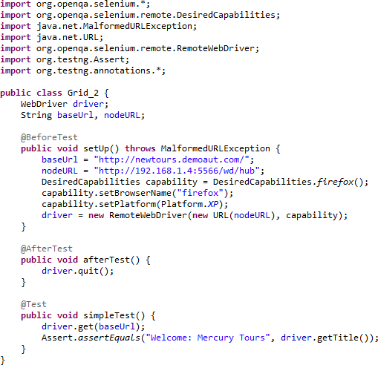

Next tab

public class testcase8 {

public static void main(String[] args) throws AWTException, InterruptedException {

System.out.println("Running keyboardandmouseactions > testcase8");

System.setProperty("webdriver.chrome.driver", "D:\\chromedriver\\chromedriver.exe");

WebDriver driver=new ChromeDriver();

driver.manage().window().maximize();

driver.get("https://www.facebook.com/");

WebElement link=driver.findElement(By.xpath("//a[contains(text(),\"Forgotten account?\")]"));

Actions a=new Actions(driver);

// defective code start

Action builder=a.moveToElement(link).contextClick(link).sendKeys(Keys.ARROW_DOWN).sendKeys(Keys.ENTER).build();

// defective code end

builder.perform();

or

WebElement link=driver.findElement(By.xpath("//a[contains(text(),\"Forgotten account?\")]"));

Actions actions = new Actions(driver);

actions.keyDown(Keys.LEFT_CONTROL)

.click(element)

.keyUp(Keys.LEFT_CONTROL)

.build()

.perform();

ArrayList<String> tab = new ArrayList<>(driver.getWindowHandles());

driver.switchTo().window(tab.get(1));